INVESTMENT MEMORANDUM (IM)

Project Title
Development of a Full-Scope Aircraft MRO Facility at Long Thanh International Airport, Vietnam
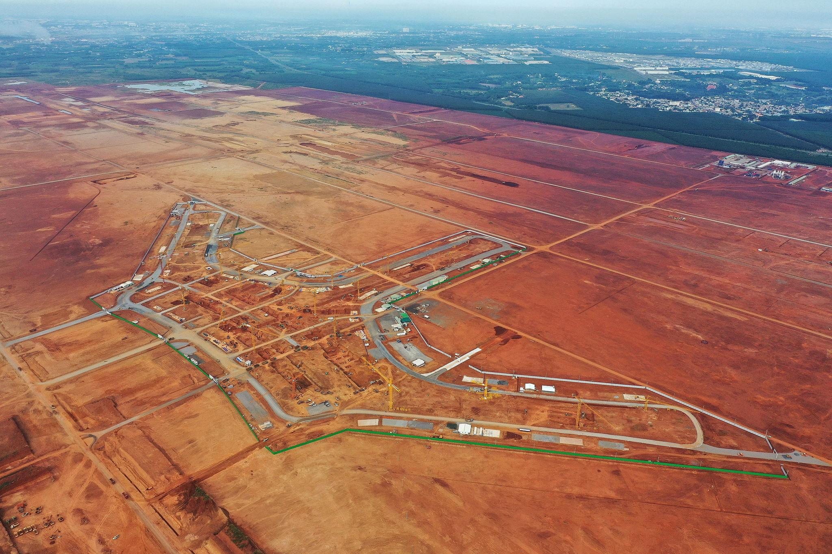
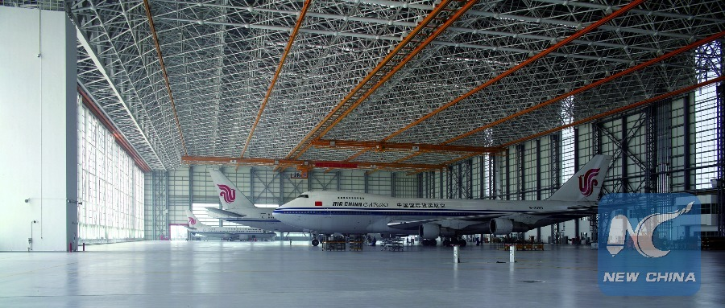


1. Executive Summary
This Investment Memorandum presents a USD 500 million greenfield Aircraft Maintenance, Repair & Overhaul (MRO) project to be developed at Long Thanh International Airport, Vietnam’s new primary aviation gateway.
The project is financed through a revolving SBLC-backed structured trading program, allowing rapid capital deployment, non-dilutive funding, and predictable cash generation during construction.
Key Highlights
- Total Investment: USD 500M
- Development Period: 24 months
- Trading Amount: USD 200M (fixed)
- SBLC Issuer / Backing:
  - DBS Bank (preferred)
  - or Techcombank
- Full capital coverage within first 6 months

2. Strategic Rationale

Market Need
- Southeast Asia aircraft fleet growth > global average
- Chronic shortage of independent MRO capacity
- Over-reliance on Singapore, China, and Korea

Location Advantage
- Long Thanh positioned as Vietnam’s main international hub
- Lower labor and operating costs
- Strong government support for aviation infrastructure
- Geographic access to ASEAN + Southern China

3. Project Scope

Phase 1 (Months 1–6)
- Land lease & master planning
- Construction of:
  - 2 wide-body hangars
  - 4 narrow-body hangars
- Tooling, GSE, IT systems
- Regulatory certifications (CAAV / EASA roadmap)

Phase 2 (Months 7–24)
- Engine & component shops
- Line + base maintenance contracts
- Workforce expansion
- Commercial ramp-up

4. Capital Expenditure (USD)
Category | Amount
Land & infrastructure | 90M
Hangars & construction | 210M
Tooling & equipment | 85M
Certification & compliance | 25M
Working capital & contingency | 90M
Total | 500M

5. Financing Structure (SBLC-Backed)
- SBLC Face Value: USD 250–350M (revolving, non-consumptive)
- Trading Amount: USD 200M
- Tenor: 24 months
- Purpose:
  - Fund construction
  - Preserve equity
  - Generate interim cash flow

6. Payout Economics (Summary)
Period | Cash Inflow
Months 1–6 | 480M
Months 7–24 | 180M
Total 24 months | 660M
- Project fully funded within 6 months
- Net surplus after capex: USD 160M

7. Exit & Asset Value
- Post-completion asset valuation: USD 1.2–1.6B
- EBITDA margin benchmark: 18–25%
- Exit options:
  - Strategic sale
  - OEM / airline JV
  - Infrastructure fund refinancing
  - IPO (Vietnam / Singapore)

3️ CASH-FLOW WATERFALL & ESCROW MECHANICS

1. Account Structure
All flows managed via a controlled escrow architecture with a top-tier bank.

Accounts
- Master Escrow Account
(DBS / Techcombank – escrow controlled)
- Project Capex Account
- Operating Reserve Account
- Investor Distribution Account
- SBLC Fees & Charges Account

2. Monthly Cash-Flow Waterfall (Priority Order)

Step 1 – Gross Trading Proceeds
- Paid monthly into Master Escrow Account

Step 2 – Mandatory Deductions
- Trading platform fees
- Bank & escrow fees
- Compliance / audit costs

Step 3 – Capital Expenditure Funding (Months 1–6)
- Automatic sweep to Project Capex Account
- Target: USD 500M fully funded by Month 6

Step 4 – Reserve Allocation
- Minimum liquidity buffer:
  - 3 months fixed payout coverage
- Held in Operating Reserve Account

Step 5 – Fixed Monthly Payout (Months 7–24)
- USD 10M / month
- Paid from escrow to Investor Distribution Account

Step 6 – Surplus Distribution
- Excess funds allocated per shareholder agreement:
  - Investor dividends
  - Expansion capex
  - Early refinancing buffer

3. Security & Risk Controls
- SBLC remains non-consumptive
- Trading exposure capped at USD 200M
- Escrow controlled by issuing / backing bank
- No commingling of funds
- Independent monthly reporting

4. Capital Protection Summary
Risk | Mitigation
Capital loss | SBLC-backed
Liquidity | Reserve accounts
Construction overrun | Early full funding
Regulatory delay | Phased deployment
Market volatility | Fixed payout phase

This is a good basis for discussion with Executive Management.

